Microglia Info and Gene Markers

Info about Microglia in the brain:

-microglia are macrophages in the brain and are mononuclear phagocytes.1

-microglia arise from yolk sac erythro myeloid (relating to red blood cells in bone marrow) precursors under normal conditions1.

-The functional significance of different types of microglia is still unknown, but they work as macrophages to help protect the brain against peripheral cells that can infiltrate the CNS.

-microglia interact with almost all CNS components during embryonic and postnatal development, where they carry out some non-immune tasks that contribute to brain function1

-microglia comprise of 5-20% of the total glial cell population in the CNS, and are as numerous as neurons2

-Some Microglia functions are as follows2:

-generate innate and adaptive immune responses

- they mediate both innate and adaptive responses during CNS injury and disease while remaining quiescent in the steady state.

-develop the mechanism and process of antigen presentation to generate the specific response from the adaptive immune system

-In glioma tumors, it was found that (through a histological study) microglia infiltrated the glioma in a localized diffusely manner (as opposed to the areas of necrosis)2

-the phagocytosis of the glioma cells and/or debris was not observed2

-glioma-infiltrating microglia/macrophages might be promoting tumor growth2

-facilitating immunosuppression (means suppression of immune response) of the tumor microenvironment.

-microglial cells are attractive for immunotherapy because they bridge the immune privileged CNS and the peripheral immune system. They are also highly present in glioma tumors2, which shows that they migrate to these tumors.

-They exhibit anti-tumor functions by phagocytosis and the release of cytotoxic factors.3

-microglia/macrophages can become tumor-supportive and immunosuppressive cells by certain tumor-derived soluble factors (tumors can make microglia immunosuppressive), thereby promoting tumor progression.

-activated microglia/macrophages participate in the process of tumor angiogenesis (new blood vessels in the tumor), metastasis (movement of the tumor from original location to form secondary colonies), dormancy, and relapse3

Stages of Microglia: Microglia can be resting or activated.

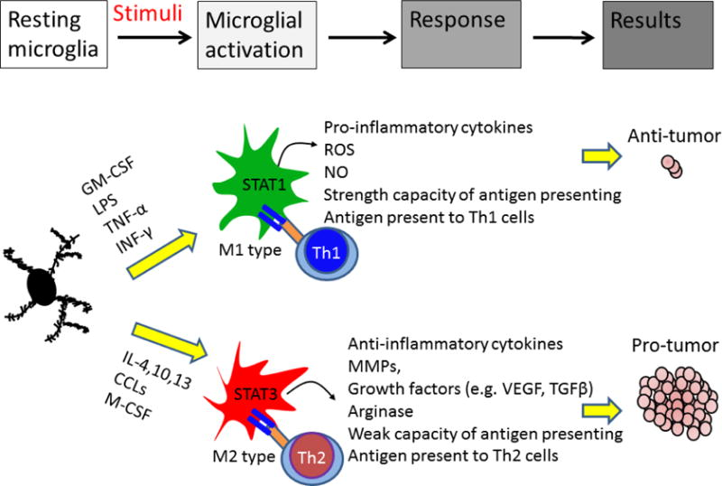

This figure shows the differential roles of activated microglia/macrophages in the brain tumor and which factors can activate a resting microglia to either pro-tumor (anti-inflammatory) or anti-tumor (pro-inflammatory)3

-resting microglia are the fastest moving cells in the brain4

-astrocytes (type of glial cell) signal to the microglia by releasing ATP (and possibly some other molecules) through connexin hemichannels.4

-microglial cells receive signal of disruption, they initiate the gradual transformation of resting microglia into an ameboid form; this process is ‘microglial activation’ 4

-the first stage of microglial activation resting microglia retract their processes, increase the size of their cell bodies, change the expression of various enzymes and receptors, and begin to produce immune response molecules.4

-Some microglial cells return into a proliferative mode, and microglial numbers around the lesion site start to multiply. 4

-Microglial cells become motile, and using amoeboid-like movements they gather around sites of damage. If the damage persists and CNS cells begin to die, microglial cells undergo further transformation and become phagocytes. 4

Microglia Marker Genes:

* **Sparc**5 → SPARC is a matricellular protein that modulates the activity of growth factors, cytokines, and ECM to assist in tissue development and repair. SPARC is highly localized in *mature ramified microglia6*
* **Iba 1**5 (expressed in microglia and macrophages)→ Microglial cells are the only brain cells to express Iba-1, expression is *up-regulated in activated microglia* enabling differentiation between cells engaged in routine surveillance and those which are activated in response to injury7
* **CD11b**8 (Expressed in both microglia and macrophages)→ increased expression of CD11b, the *β*-integrin marker of microglia, represents microglial activation during neurodegenerative inflammation.9
* **P2ry12**8 (specific microglial marker) → expression decreased during microglial activation
* **TMEM119**8 (specific microglia marker) → transmembrane protein 119 (Tmem119), a cell-surface protein of unknown function, as a highly expressed microglia-specific marker in both mouse and human.11
* **CD45**8 → microglia express this gene as a response to neuroinflammation
* **Slc2a5**8
* **Fcrls**8
* **SalI 1**8
* **Siglech**8

Cell Surface Localization of microglia- specific gene products8 → meaning these are common genes which code for proteins found on the microglial cell surface in response to neuroinflammation

|  |  |
| --- | --- |
| **Microglia cell surface enriched genes** | |
| **Gene symbol** | **Gene name** |
| **Ecscr** | Endothelial cell surface expressed chemotaxis and apoptosis regulator |
| **Scamp5** | Secretory carrier membrane protein 5 |
| **Ptprm** | Protein tyrosine phosphatase, receptor type M |
| **Kcnd1** | Potassium voltage-gated channel subfamily D, member 1 |
| **Sdk1** | Sidekick cell adhesion molecule 1 |
| **Clstn1** | Calsyntenin-1 |
| **Sgce** | Sarcoglycan epsilon |
| **Slc12a2** | Solute carrier family 12, member 2 |
| **Cadm1** | Cell adhesion molecule 1 |
| **Sema4g** | Semaphorin 4G |
| **Pros1** | Protein S |
| **Slco2b1** | Solute carrier organic anion transporter family, member 2b1 |
| **Rtn4rl1** | Reticulon 4 Receptor Like 1 |
| **Cmtm4** | CKLF-like MARVEL transmembrane domain-containing protein 4 |
| **Fat3** | Fat atypical cadherin 3 |
| **Smo** | Smoothened homolog |
| **Mrc2** | Mannose receptor C type 2 |
| **Jam2** | Junctional adhesion molecule 2 |
| **Plxna4** | Plexin A4 |
| **Slc46a1** | Solute carrier family 46, member 1 |
| **Agmo** | Alkylglycerol monooxygenase (Tmem195) |
| **Gpr165** | G protein-coupled receptor 165 |
| **Tmem204** | Transmembrane Protein 204 |
| **P2ry12** | P2Y purinoceptor 12 |

Functional differences and similarities in the microglial and macrophage immune response gene profiles during neuroinflammation8 (Figure on next page)

*“****a*** *Venn diagram of the immune response genes in infiltrating macrophages and reactive microglia that were identified in Fig.* [*7*](https://jneuroinflammation.biomedcentral.com/articles/10.1186/s12974-019-1545-x#Fig7)*. Overlapping circles represent genes that are upregulated in both infiltrating macrophages and reactive microglia.* ***b*** *List of genes from the Venn diagram that are exclusively expressed by infiltrating macrophages (blue column), microglia (light yellow column), and by both cell populations (dark yellow column).”*

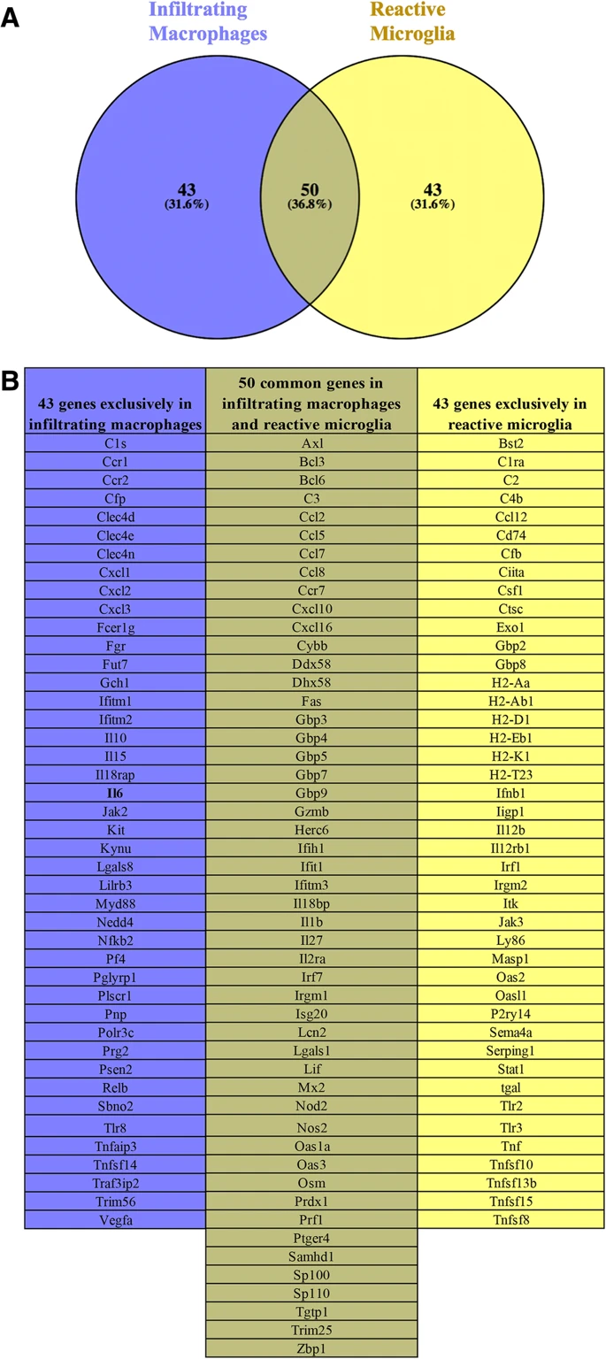

Immunohistochemical markers for monocyte/macrophage lineage10:

-**Ki-M1P** → Macrophages, *microglia*, epithelioid cells, plasmacytic T cells

-**HLA-DR** → Monocytes, macrophages and *activated microglia* and others

-KP1 → macrophages

-My4 → macrophages

-My7 → macrophages

-Ki-M1 → monocytes, NK cells

-Ki-M6 → macrophages

-**EBM 11** → *microglia*, macrophages

These markers can be characterized into four subtypes of the microglia/macrophage cell system10:

1. Ramified or resident microglia
2. Ameboid microglia
3. Perivascular microglia
4. Brain macrophages

Normal Brain Tissue: 10

* Distribution of Ki-M1P positive showed that ramified microglia were more present in white matter than in the cortex
* Ameboid microglia (positive expression for HLA-DR) were barely observed
* KP1-positive cells (macrophages and perivascular microglia) were mostly restricted to the perivascular space.

Medulloblastomas:10

* Macrophages and ameboid microglia were diffusely distributed (spread out and not concentrated in one place) throughout the tumor. However, restricted to the connective tissue and to the vascular system
* Ramified microglia were rare
* Neuronal component was prominent in the medulloblastoma

→ it was determined that the distribution patterns of the subtypes of microglia/macrophages differ and are distinct based on the tumor type, which indicates that the distribution amongst different medulloblastoma subtypes may also differ

Sources:

1. <https://www.nature.com/articles/nri.2017.125> (Microglia and macrophages in brain homeostasis and disease)
2. <https://www.ncbi.nlm.nih.gov/pmc/articles/PMC3786731/> (Role of Central Nervous System Immunity and Glioma Immunology)
3. <https://www.ncbi.nlm.nih.gov/pmc/articles/PMC5658785/> (The Roles of Microglia/Macrophages in Tumor Progression of Brain Cancer and Metastatic Disease)
4. <https://www.networkglia.eu/en/microglia> (Microglia)
5. <https://www.hindawi.com/journals/sci/2018/9628289/>
6. <https://pubmed.ncbi.nlm.nih.gov/23467362/> (SPARC Regulates Microgliosis and Functional Recovery Following Cortical Ischemia)
7. <https://www.alphalabs.co.uk/media/productfile/file/a/n/anti-lba1_flyer_nov14.pdf> (Anti-Iba 1 Microglia Marker)
8. <https://jneuroinflammation.biomedcentral.com/articles/10.1186/s12974-019-1545-x> (Differential transcriptional Profiles Identify Microglial- and Macrophage-specific Gene MArkers Expressed During Virus-Induced Neuroinflammation).
9. <https://www.ncbi.nlm.nih.gov/pmc/articles/PMC1963414/#:~:text=Abstract,CD11b%20expression%20is%20poorly%20understood.> (Up-regulation of Microglial CD11b Expression by Nitric Oxide-)
10. <https://link.springer.com/article/10.1007%2Fs004010050520> (Distribution and characterization of microglia/macrophages in human brain tumors)

PDF (partial): <https://pdfs.semanticscholar.org/ce30/a32ebf3072cf948fa003c2627c3481caacf5.pdf>

(Distribution and Characterization of microglia/macrophages in human brain tumors)

1. <https://www.pnas.org/content/113/12/E1738> (New tools for studying microglia in the mouse and human CNS)